SS1: Created two linux instances

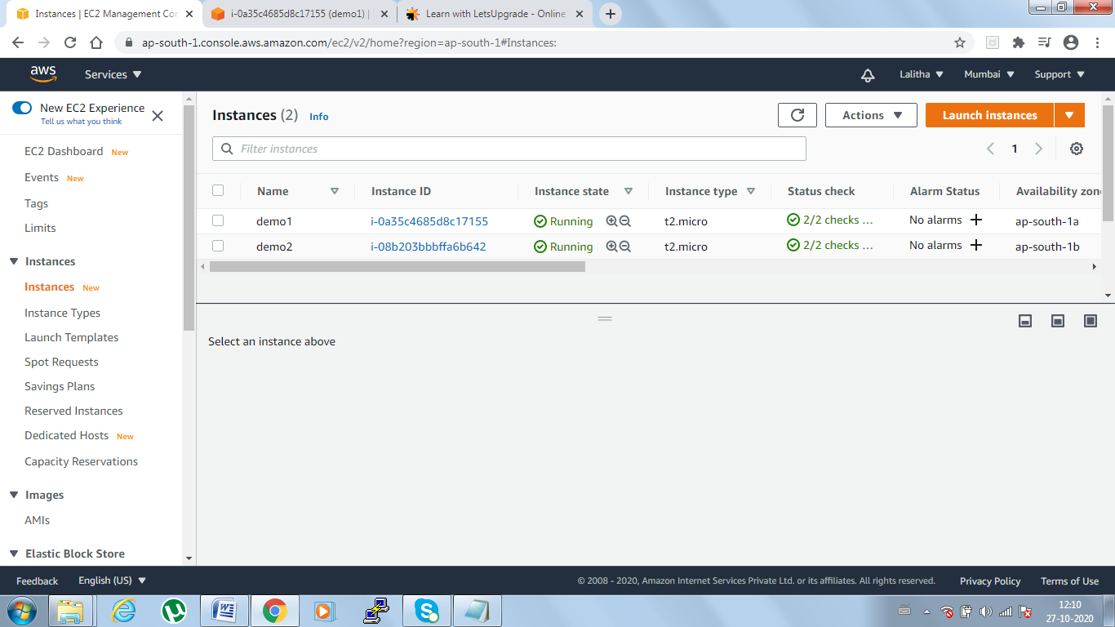

SS2 &3: Instance details for each server

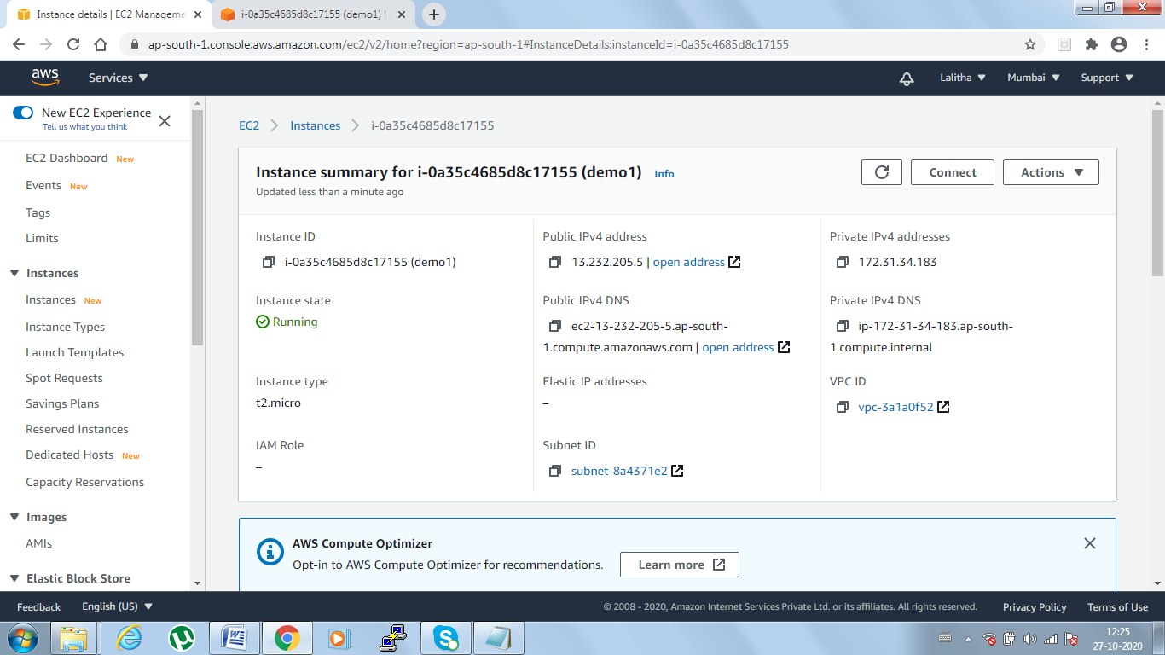

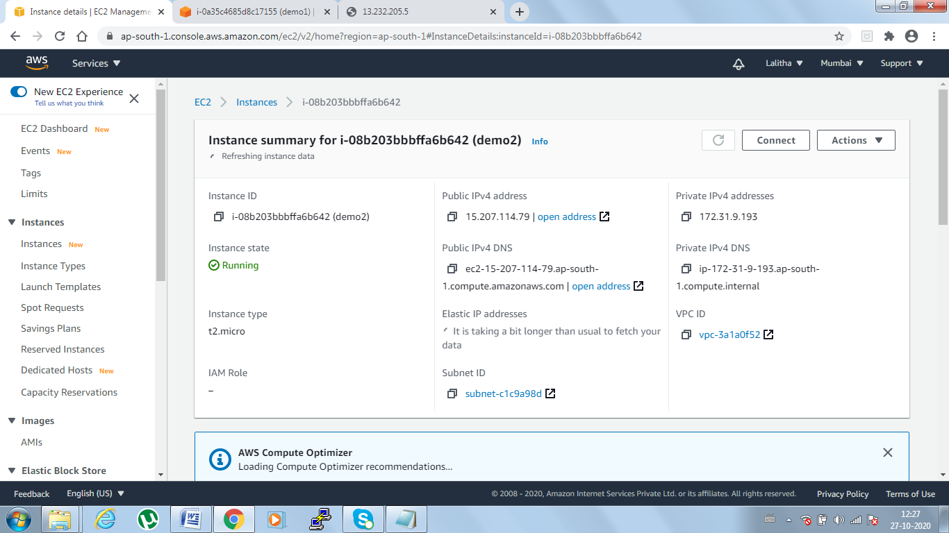

SS4: Active running of httpd service

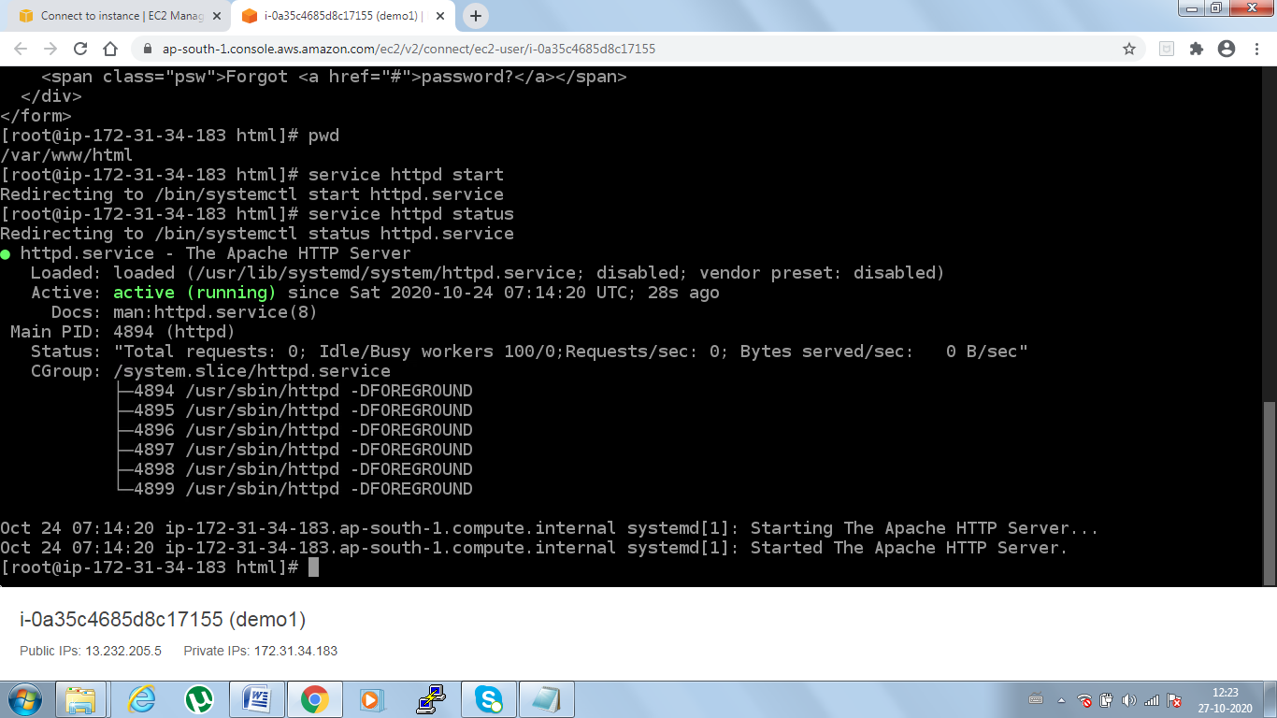

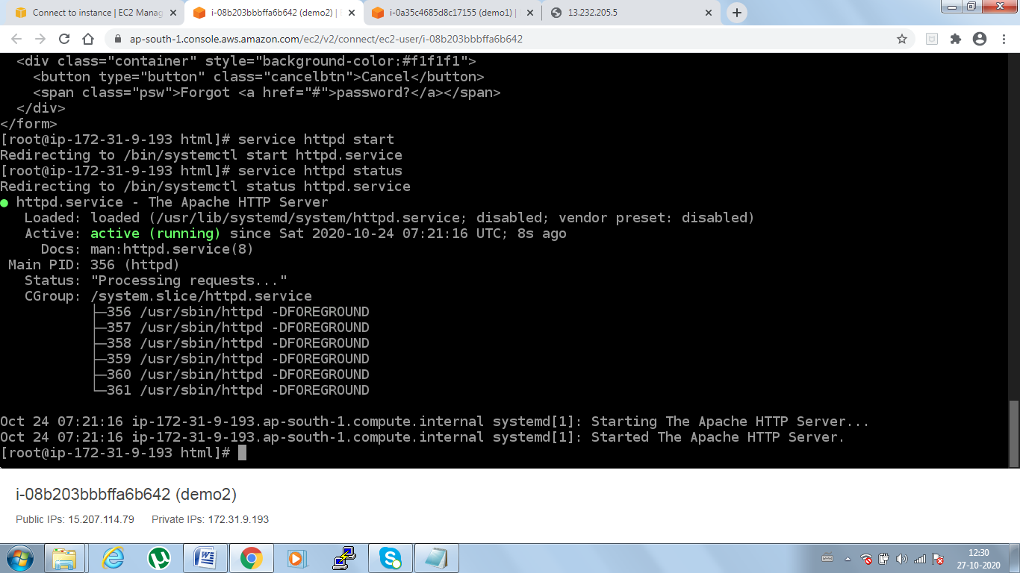

SS5:UserID and Passkey code deployed into 1st server

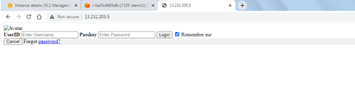

SS6:Username and password page which deployed into 2nd server

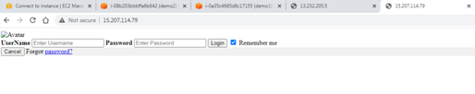

SS7: Loadbalancer  
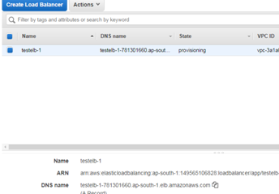

SS8:Reply from 1st Server

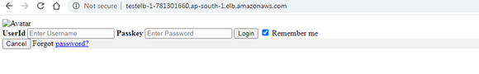

SS9:Reply from 2nd Server

